****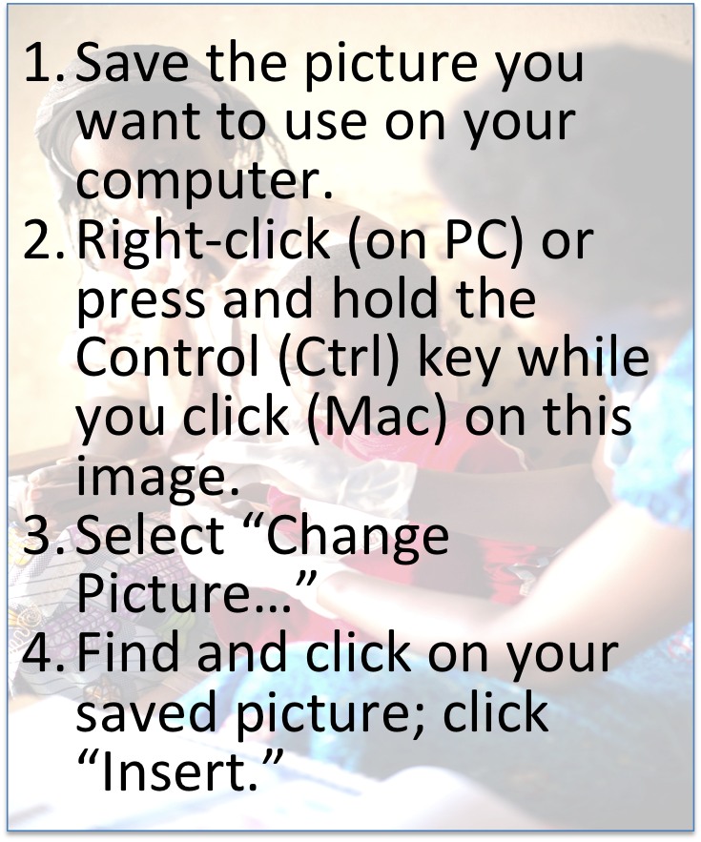

*Photo credit: [name or organization]*

Learn More

Compare

Compare [country’s] performance with that of its neighbors and other countries around the world, and learn from their experiences

Take advantage of new, practical tools for primary health care system diagnosis and improvement

Find Tools

Primary health care forms the foundation of health systems, ensuring all people stay healthy and get care when they need it.  Primary health care connects people and families with trusted health workers and supportive systems to address the majority of their health needs throughout their lives.

*[Paste or type a relevant quote or fact here, and adjust text size so that it fits in the space]*

PHCperformanceinitiative.org

Health in [Country]

[Select all the text in this text box (keyboard shortcut: CTRL+A on a PC or ⌘+A on a Mac), and paste or type over the existing text with basic information about the strengths and weaknesses of the country’s health care system, including primary health care elements.

Aim for about 750 words, and adjust the size of the font to make it fit if necessary. The text will flow automatically from this text box to the ones on the 2nd and 3rd pages.

Sources of information could include data from PHCperformanceinitiative.org, media reports, national survey data, and NGO reports; all sources should be cited as endnotes.]

Lorem ipsum dolor sit amet, consectetur adipiscing elit. Aliquam commodo mollis mauris, quis porttitor ligula feugiat sagittis. Nam tincidunt sapien non nunc pretium fringilla. Maecenas non quam id elit sagittis euismod eu vitae erat. Etiam ullamcorper eu erat vel commodo. Phasellus pellentesque nunc in facilisis ullamcorper. Etiam turpis orci, vulputate non viverra aliquet, semper nec nisi.

Vestibulum eleifend, urna ac pellentesque facilisis, tellus ex bibendum ipsum, sit amet porta felis urna vitae ligula. Suspendisse ultrices lorem at nibh suscipit pellentesque. Aliquam elementum et augue in feugiat. Vivamus vehicula aliquam tortor vel malesuada. Proin varius et massa ut vulputate. Suspendisse dapibus ipsum at nisl posuere, nec viverra nunc luctus.

Vestibulum hendrerit aliquet efficitur. Morbi at ligula at quam pellentesque tincidunt. Nunc in accumsan augue, eget molestie odio. Aliquam venenatis posuere magna, ac sollicitudin purus vulputate in. In a ultricies justo. Fusce tortor tellus, semper sed nulla ac, congue accumsan est. Vestibulum massa orci, commodo id elementum id, fermentum at lorem. Sed ut eros non nisl scelerisque tincidunt. In vehicula eu odio mollis auctor. Nunc euismod velit et lacus dignissim rhoncus. Praesent fermentum accumsan felis, ac aliquam ligula sodales id. Suspendisse dapibus ipsum at nisl posuere, nec viverra nunc luctus. Donec vulputate sed nisi id convallis. Suspendisse condimentum scelerisque urna, vel eleifend orci rutrum in. Sed quis ultrices ipsum.

Fusce elementum dolor et elementum accumsan. Nunc pharetra vulputate tellus sit amet dignissim. Ut quis massa at nibh imperdiet elementum. Sed sit amet posuere ipsum, in varius nulla. Ut pretium suscipit pretium. Sed sed tortor tempor, tempus velit non, vestibulum sapien. Lorem ipsum dolor sit amet, consectetur adipiscing elit. Suspendisse potenti. Ut ac volutpat quam. Fusce id aliquam sapien. Mauris rhoncus ex in ante luctus, id dignissim nisl viverra. Donec rutrum ligula non libero convallis facilisis. Proin efficitur mattis semper.

Interdum et malesuada fames ac ante ipsum primis in faucibus. Cras euismod ac nulla sit amet viverra. Vestibulum nec semper lorem, ut euismod purus. Maecenas congue ligula eget ornare venenatis. Etiam sit amet sodales magna, eget sollicitudin tortor. Suspendisse et feugiat mi, id accumsan turpis. Donec in dui ac lectus aliquet ullamcorper ac at elit. Integer urna metus, lacinia finibus venenatis in, tincidunt eu lectus. Phasellus consectetur mattis tincidunt. Aenean elementum purus mauris, vel sollicitudin urna facilisis sed. Maecenas facilisis volutpat maximus. In porta nibh leo, nec feugiat mi sagittis eget.

Vivamus vehicula, ipsum in tempor pulvinar, eros mi sollicitudin lacus, nec scelerisque nisl diam egestas risus. Mauris malesuada tortor nec sem vulputate, quis maximus magna pretium. Sed mattis scelerisque efficitur. Phasellus scelerisque ut libero in rutrum. Vivamus fringilla, ante quis iaculis fermentum, nisi mi sodales lectus, elementum tempus ex leo vitae mi. Aliquam odio felis, vulputate eget augue quis, tincidunt ornare lacus. In eleifend pulvinar lectus, sit amet auctor metus aliquam at. Cras tristique condimentum ligula eget convallis. Cras suscipit magna tellus, vitae maximus tortor semper suscipit. Nunc id sapien laoreet, dictum odio ut, scelerisque mauris. Suspendisse potenti.

Quisque malesuada lobortis augue, et imperdiet elit euismod id. Nunc semper eros tristique, sagittis magna sed, egestas ligula. Cras sit amet semper velit. Mauris posuere a sapien eu rutrum. Praesent non diam massa. Cras ut nulla ac dolor vulputate sodales sit amet ut leo. Donec fermentum quis purus quis accumsan. Ut sed condimentum eros, in faucibus est.

Cras tristique condimentum ligula eget convallis. Cras suscipit magna tellus, vitae maximus tortor semper suscipit. Nunc id sapien laoreet, dictum odio ut, scelerisque mauris. Suspendisse potenti. Mauris malesuada tortor nec sem vulputate, quis maximus magna pretium. Sed mattis scelerisque efficitur. Phasellus scelerisque ut libero in rutrum. Vivamus fringilla, ante quis iaculis fermentum, nisi mi sodales lectus, elementum tempus ex leo vitae mi. Aliquam odio felis, vulputate eget augue quis, tincidunt ornare lacus. Aliquam odio felis, vulputate eget augue quis, tincidunt ornare lacus. In eleifend pulvinar lectus, sit amet auctor metus aliquam at.

[Month Year]

**Primary Health Care:**

**The Opportunity in [Country]**

Learn more about [country’s] primary health care system performance

For more info:

[Photo credit]

*(continued on next page)*

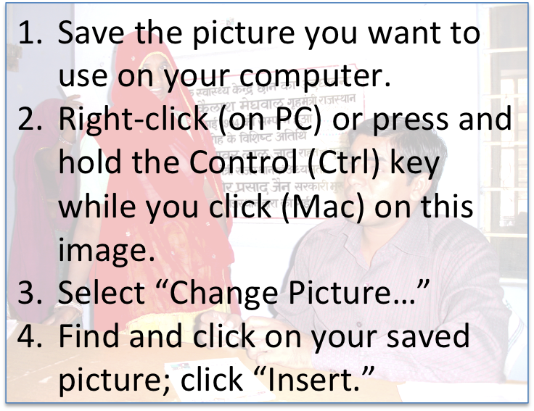

**Page 2**

**Primary Health Care: The Opportunity in [Country]**

**[Sidebar Title]**

Photo credit: [Name or organization]

[Select all the text in this text box (keyboard shortcut: CTRL+A on a PC or ⌘+A on a Mac), and paste or type over the existing text with information about an aspect of primary health care in the country that is particularly interesting.

For example, is the country performing particularly well or poorly on one of the indicators showcased at PHCperformanceinitiative.org? Has the country implemented policies that are significantly affecting primary health are system performance? Are there particular obstacles to primary health care improvement in the country, such as an armed conflict, drought, or challenging physical environment?

This section has two text boxes, and text will flow automatically from the top one into the bottom one.]

Donec in pellentesque nulla. Duis at vulputate orci. Mauris non porta ex.

*(continued on next page)*

**Page 3**

**Primary Health Care: The Opportunity in [Country]**

[Select all the text in this text box (keyboard shortcut: CTRL+A on a PC or ⌘+A on a Mac), and paste or type over the existing text with information about global, regional, and national health and development goals that are more likely to be achieved if the country has a high-performing primary health care system.

For example, the third Sustainable Development Goal (see full list at www.un.org/sustainabledevelopment/sustainable-development-goals) of healthy lives and well-being for all at all ages will be difficult to achieve without strong primary health care globally.

Other examples might be objectives from the country’s national strategic plans on HIV, malaria, non-communicable diseases, or other health issues; or commitments the country made to the Family Planning 2020 initiative (see country commitments at www.familyplanning2020.org/commitments?entity_type[]=Country).

Maecenas lobortis malesuada maximus. Aenean blandit eros a massa iaculis, id molestie sem porttitor. Aenean a risus volutpat, vehicula sem ut, eleifend dui. Donec in sodales neque. Duis magna felis, varius sit amet aliquet ut, varius quis metus. Pellentesque laoreet vel dolor sed lacinia. Duis eleifend scelerisque mi eu tristique. Ut mollis, mauris quis sodales iaculis, nulla elit pretium felis, eu tempus metus purus eu ligula. Etiam tristique dolor ac lacinia vehicula. Vestibulum in ligula dapibus, fringilla sapien ut, lobortis risus. Etiam lacus ante, pulvinar eu turpis a, aliquet dapibus, ullamcorper vel lectus finibus, varius aliquam odio. Pellentesque ipsum massa, pretium quis felis nec, pulvinar semper orci.

**[Country’s] Health Goals**

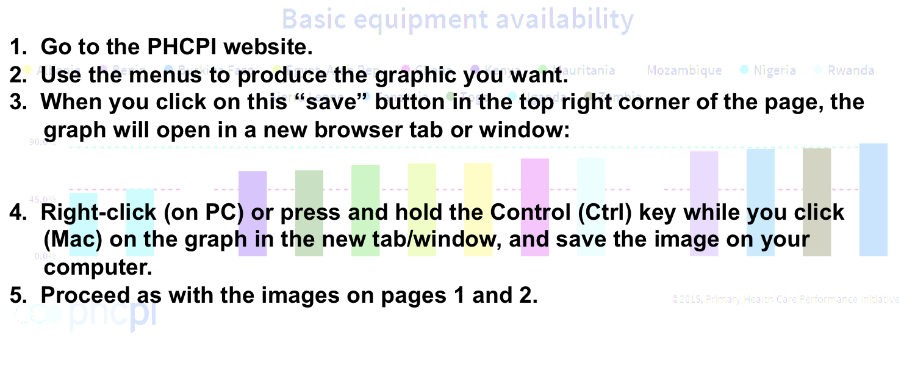

[Use one of the charts available at PHCperformanceinitiative.org to illustrate something about primary health care in the country. For example, you could show performance compared to other countries on a particular indicator. Replace the text here with a description of what is relevant about the chart.]

**Primary Health Care: The Opportunity in [Country]**

**Page 4**

**Recommendations for Decision-Makers in [Country]**

[Select all the text in this text box (keyboard shortcut: CTRL+A on a PC or ⌘+A on a Mac), and paste or type over the existing text with recommendations for the decision-makers you will target with your advocacy. For generic suggested recommendations, see “Primary Health Care Advocacy Guidance” in the PHCPI advocacy toolkit, but this document will be more powerful if you can tailor the recommendations to the particular policy needs in your country.]

Suspendisse eget pretium nisl. Proin eu varius enim. Curabitur ac enim nec urna vulputate aliquam. Aliquam erat volutpat.

Quisque venenatis ligula gravida eros tempor, et rutrum dui euismod. Donec vitae turpis orci. Morbi tempus urna luctus, scelerisque magna in, pellentesque lorem. Mauris interdum justo tortor, et sodales quam tristique vitae. Vivamus sed efficitur metus, eget tincidunt turpis. Cum sociis natoque penatibus et magnis dis parturient montes, nascetur ridiculus mus. Morbi sit amet vehicula nunc.

Cras non eleifend eros. Phasellus vel justo tempus, finibus augue id, imperdiet lacus. Vestibulum mi nisi, mattis ac ex in, porta varius felis. Nullam in quam pharetra, tempus dui et, vehicula augue. Nulla a erat est. Etiam elementum sapien ac nibh varius semper. In lacinia mi quis magna varius, sit amet convallis tellus fringilla. Nunc id felis eget arcu commodo pellentesque. Donec euismod ex in elementum facilisis. Etiam turpis ipsum, commodo at nibh in, porta interdum ante. Aenean commodo enim id consectetur faucibus.